**PROGRAMMING METHODOLOGY & PRACTICE PROJECT 1 REPORT**

Champ Bodhibaum Loa (1TE19247Y)

The goal of this project is for people to have fun and learn something at the same time. This project is a fighting game which contains simple math problems to solve. When people play this game with their friends, they can enjoy the game while improving their brain performance. Mental arithmetic is arithmetical calculations performed by your mind or brain without help from calculator or any writings and this game is all about mental arithmetic. The reasons why math problems are chosen as the questions are first, because mental arithmetic keep your brain quick and sharp. It is because your brain will perform better when it is often used and math problems are very good at exercising your brain. Second, mental math also improves your number sense. Number sense is the ability to understand the relationships of quantities, so good number sense will make you understand better about numbers. Mental math is also very useful for daily life situations like when shopping, cooking, exchanging currency, etc.

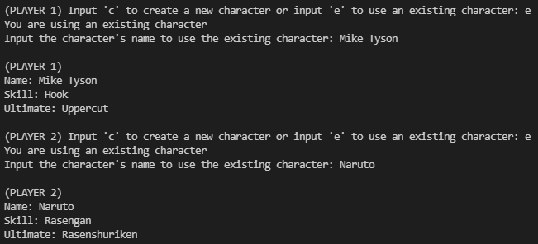 The number of players required to play the game is two players. Each player first has to create a character or if he/she already have a character, he/she can use the existing character. Each character has health and they can customize their health amount but the recommended health is 10. Then, both of the players will take turns solving math problems. They are given 5 seconds to solve the problem and if he/she failed to answer the problem correctly within 5 seconds, he/she will not be able to attack the other opponent. If a player answered the problem correctly within 5 seconds, he/she can use skill (deal 1 damage) or ultimate skill (deal 2 damage) to the opponent. The game will end when one of the characters has 0 health.

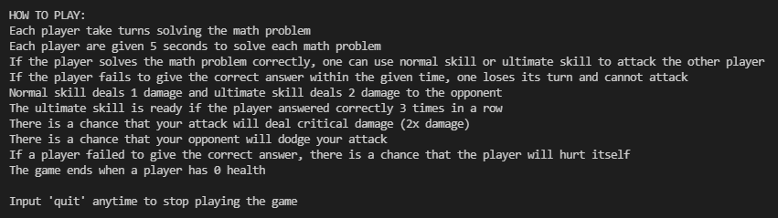

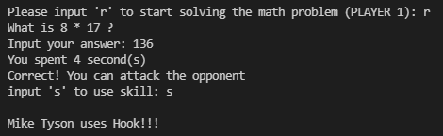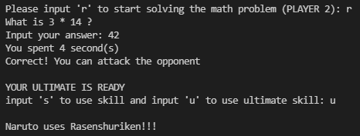

There were several things that I looked up on the internet. In the coding, time module and threading module are used for the background timer. In the game, there is a 5 seconds timer for the players when solving the problem. Time module is used to create the timer and threading is used so that the timer and the problem-solving part run at the same time. Random module is also used for creating the math problems. The randomized numbers are combined with basic mathematical operations to create basic mathematical problems. Random module is also used for the rate of critical damage, dodge, and the type of the math problems (+, -, *)



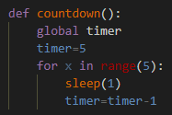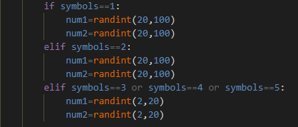

Even though this game works perfectly fine, there is always improvement that can be made to this game. The first feature that can be added in the future is more difficulty options. Currently, the game only has one difficulty and more difficulty options can be made such as easy mode, normal mode, hard mode, and expert mode. Easy mode is probably for kids and for people that are not that good at math and expert mode is for people that are good at math and want challenge, and they just want to have fun playing with their friends. Second improvement that can be made is motion graphics. This can be added to make the game more interesting. Since this game still runs on terminal, it only contains words and numbers. However, in the future, things like display, character movement, and visual effects can be added to the game so it is more appealing and more enjoyable to people.